SmartLine Finish Line Timer
Highboy Plans
The Highboy raises the displays 30 inches high.

Supplies
- 1"x3” wood of good quality or ¾” plywood (Plywood is preferred).
The amount required depends on the width of the timer and whether you buy sheets of plywood or 1”x3” pieces of wood.
An estimate for a 4-lane timer is one ¼ sheet of plywood (2 feet x 4 feet) or a 10-foot length of 1”x3” wood.
You will need to measure the timer to determine the amount you need if you change the height or width.
- ¼” plywood
The amount required depends on the width of the timer.
An estimate for a 4-lane timer is one ¼ sheet of plywood (2 feet x 4 feet).
- 20 Phillips flathead wood screws
- Sand paper and Paint for finishing

Building Procedure
- If you are using a ¾” plywood sheet, cut it into 2"-3" by 48" pieces. From these 48" lengths you can cut one 30" and one 17" length.
- Cut two pieces of the 1”x3” into 30-inch lengths. These will be used for the left and right vertical pieces.
- Cut two pieces of the 1”x3” for the Bottom Horizontal and Horizontal Above Displays that are the width of the timer. We used 17-inch lengths for our 4-lane timer. If your timer is longer than 18" and you used the plywood sheet, you would have to use another 48" strip.
- Cut one piece of the 1”x3” that is 1.5 inches less than the width of the timer. The measurement for our Horizontal Below Displays is 15.5".
- Cut two pieces that are 4.25" long for the Left and Right Display Mount pieces.
- Cut a 1"x1" notch in the Right Display Mount. (Right side looking at front.) For steps 1-6 refer to Figure 1.
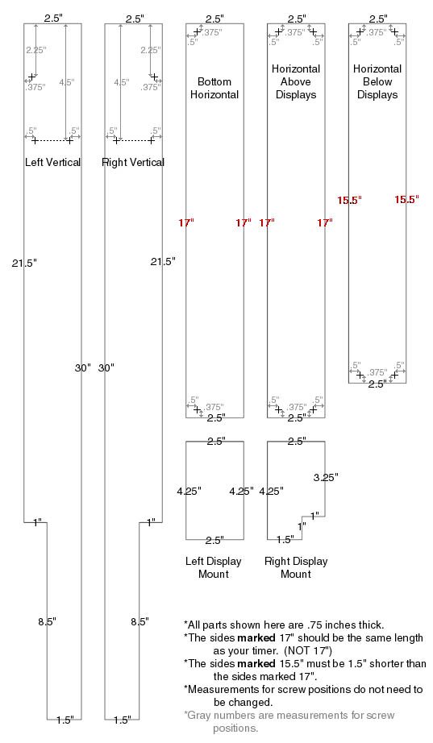
Figure 1
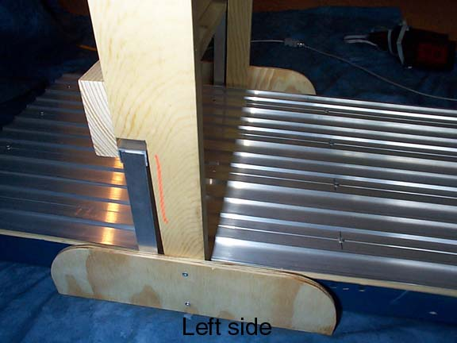The lengths of the vertical 1”x3” pieces only need to be the same as each other. On the highboy shown, the vertical pieces are 30 inches long.
A corner is cut out of the back edge of the vertical pieces for the timer. The cut is 8.5 inches by 1 inch. The Bottom Horizontal piece is attached so that there is a ¾” overhang used as an extra support for the timer.
- Cut two pieces that are 4.5" long by 3.5" wide for the Left and Right Foot pieces. Curve the top of each foot.
- Cut a .5" notch in the Right Foot for the communication cable.
- Cut one piece that is 1.75" less than the length of the finish line
(ours is 15.25") long by 3.25" wide for the Display Mount.
- Cut a 1"x1" notch in the corner of the Display Mount.
- Cut one piece that is the length of the finish line (ours is 17") long by 6" wide for the Back Cover.
- Cut a 1" x 1.75" notch that is .75" in from the edge of the Back Cover. For steps 7-12 refer to Figure 2.
- Assemble the Highboy as shown using Phillips flathead wood screws.
- The Left and Right display mounts are placed between the Back Cover and the Display Mount. They are screwed in place on the side, 2.25” down from the top.
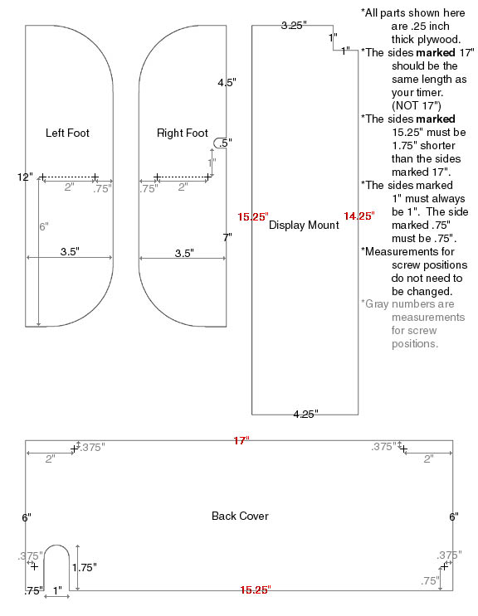
Figure 2
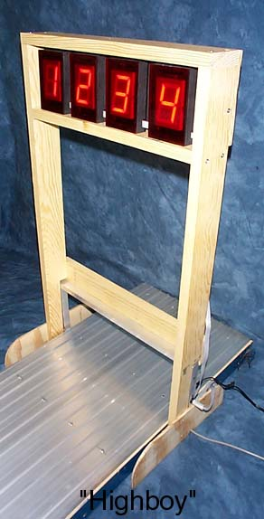
eTekGadget 36 Matuk Drive Hyde Park, NY 12538 (845)-229-5189
www.eTekGadget.com

Copyright © 2004 eTekGadget. All Rights Reserved.

